**Phan Huy Khánh – 22IT.B107 – Lab 4 – Ex 6-1**

1. Open the display_result.php file.

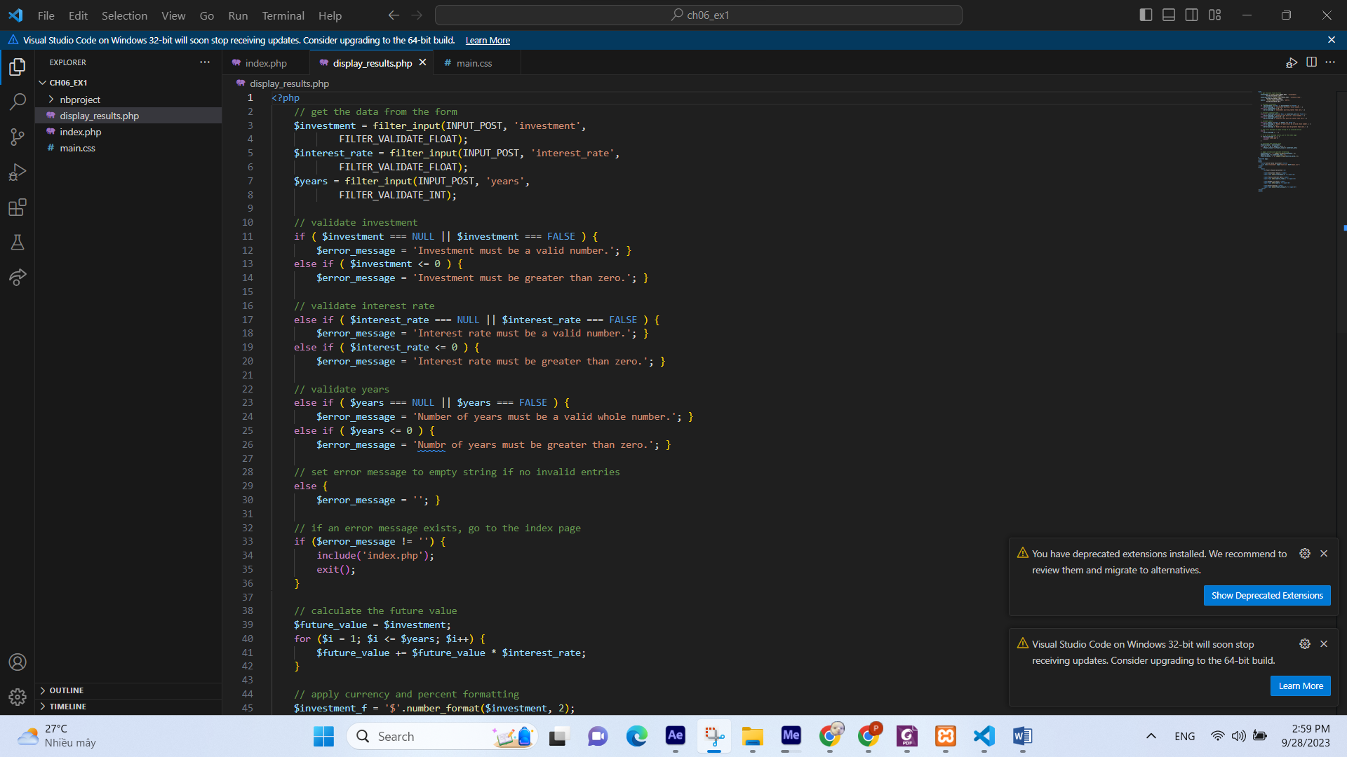

1. Add echo statements to trace the execution of the code. Then run the application to see how the echo statements work.

